PROJECT REQS

**Auto Rental Management System**

System allows for the rental of vehicles by drivers. Staff would have the ability to perform CRUD (Create, Read, Update, Delete) operations on each vehicle and assign a rental cost based on time: per day (minimum), per week, or per month. Staff would also have the ability to sign out vehicles to users and to offer them additional insurance and other features (such as GPS navigation, pre-fill gas, etc…) as well as to provide inspection reports before and after the vehicle is loaned out.

**SYSTEM REQUIREMENTS**

* Customers should be able to rent any vehicles
* Customers should be able to search any vehicles
* Customers should be able to reserve any vehicles
* Customers should be able to cancel any reservation
* Customers should add add-ons (GPS, Carseat, Additional Insurance)
* Customers should determine the duration of rental
* Staff should do before and after inspection
* Staff should know about existing inventory (Read)
* Staff should able to modify (Create, Update, Delete) vehicle inventory
* Staff and customer should be able to calculate cost

**SW DESIGN**

* Class diagrams…
* UML (Unified Modelling Language)
* Which database to use  
   (<http://muharremdemiray.blogspot.com/2017/04/automatic-cover-letter-generator-job.html>)
  + <http://muharremdemiray.blogspot.com/2016/12/how-to-setup-mongodb-tools-to-develop.html>
* <https://www.draw.io/>

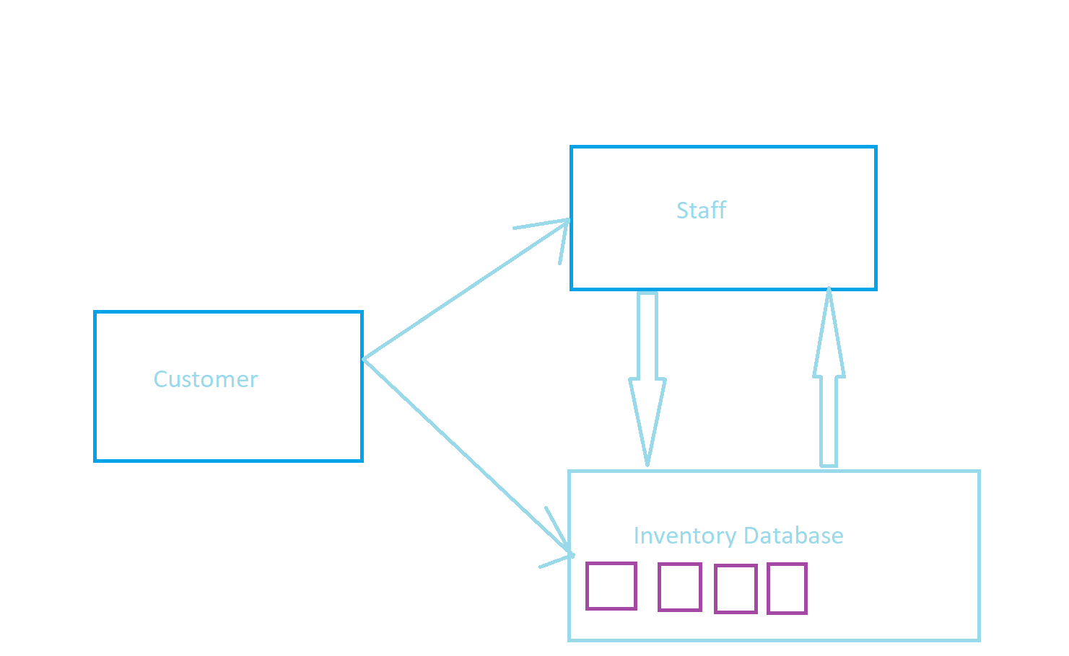

**SOFTWARE REQUIREMENTS**

* Min duration should be 1 day
* Duration should only be full days

**SW Implementation**

**SW Testing (QA Assurance)**

* Unit Testing
* Integration Testing

**Release and Maintenance Plan**

Version Control tools (GitHub)

Git Clients